Experiment #3 – Function Generator

Moein Karami,

810198540

# Waveform Generator

Look at figures 1 to 9 in next page.

# Waveform Generator

In waveforms of figures 10 to 12 parallel input of divider is 250 so clock frequency will be 5MHz. Expected frequency for rhomboid , square and reciprocal wave is 19500Hz.

In waveforms of figures 13 to 15 parallel input of divider is 230 so clock frequency will be 1MHz. Expected frequency for triangle wave is 2KHz and for full wave rectified is 4KHz and for half wave rectified is 2KHz.

In waveforms of figures 16 to 17 parallel input of divider is 205 so clock frequency will be 500KHz. Expected frequency for sinusoidally modulated square wave is 4KHz and for other one is 2KHz.

In figures 18, 19 and 20 Phase_cntrl is equal to 2, 4 and 8. So we expect the frequency of these waveforms be multiplied to 2, 4 and 8 (frequency of DND wave is equal to 50KHz).

# Amplitude Selector

Amplitude Selector input is equal to 00, 01, 10, 11 in figures 21, 22, 23, 24 respectively.

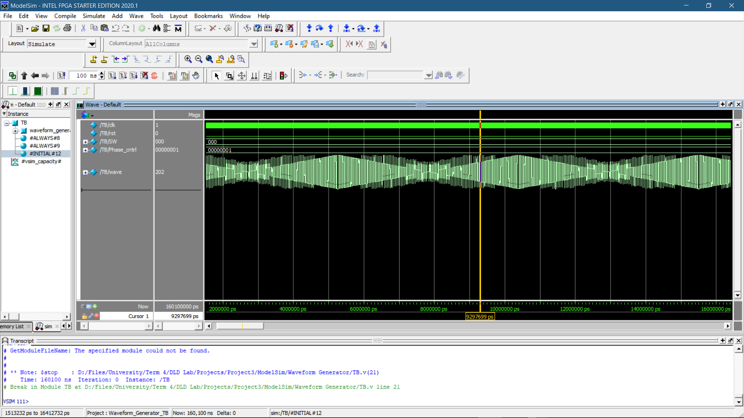

Fig. 1 Rhomboid waveform

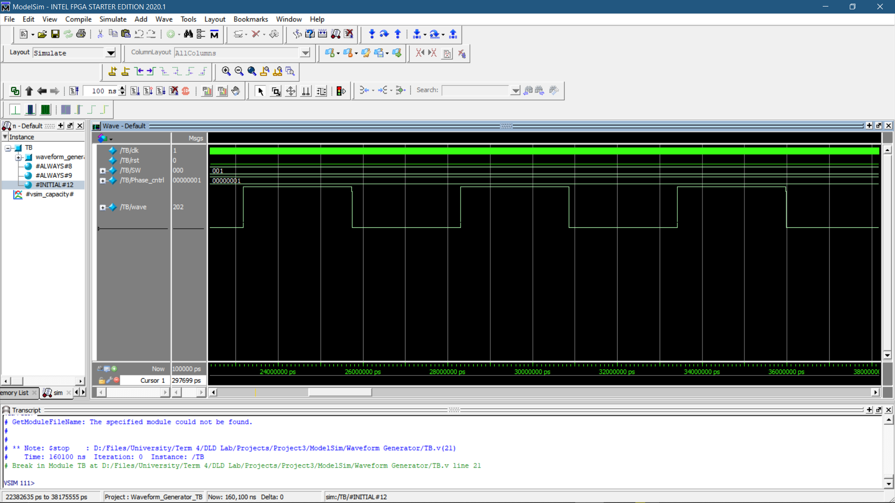

Fig. 2 Square waveform

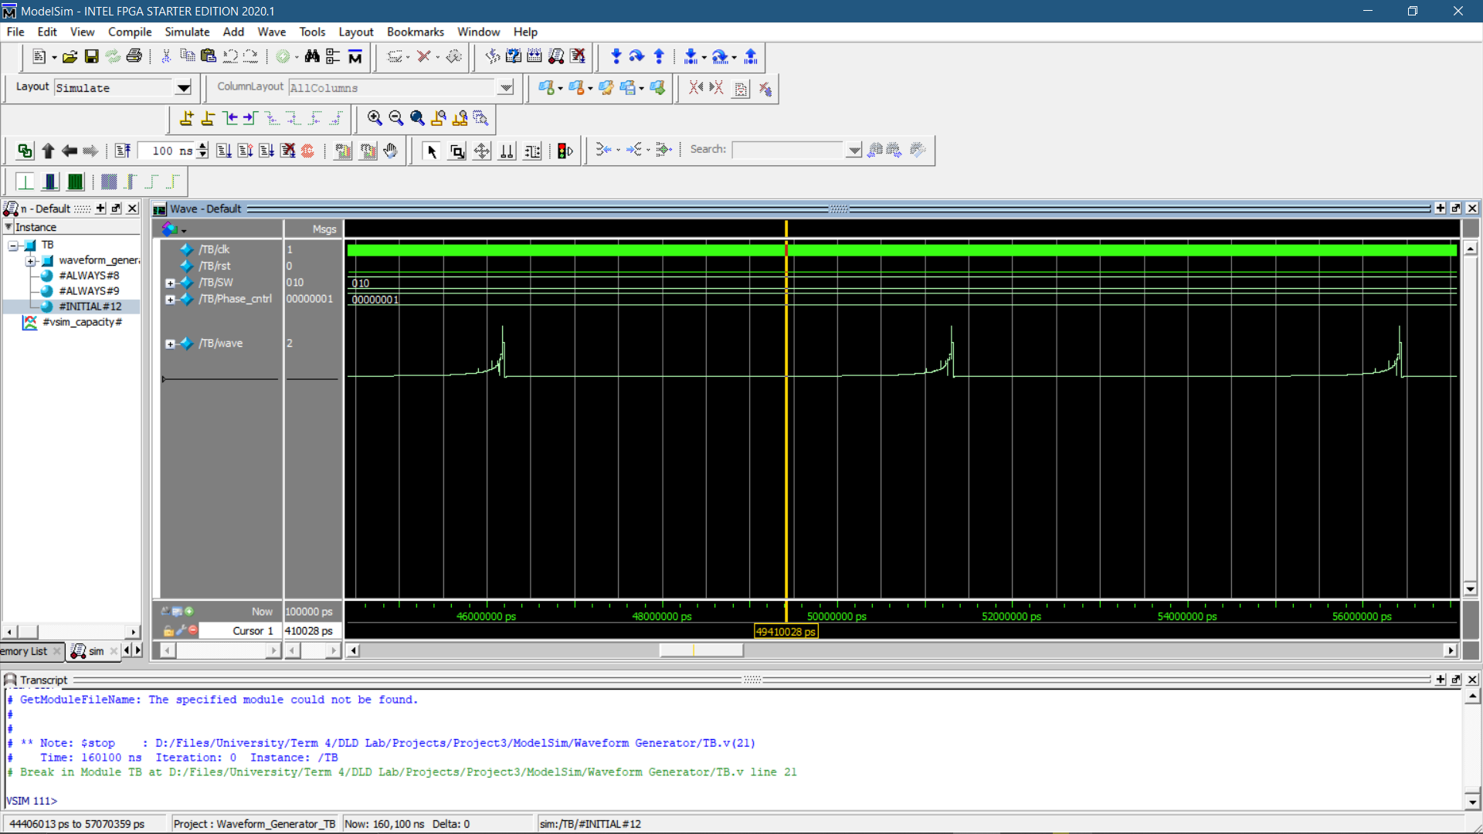

Fig. 3 Reciprocal waveform

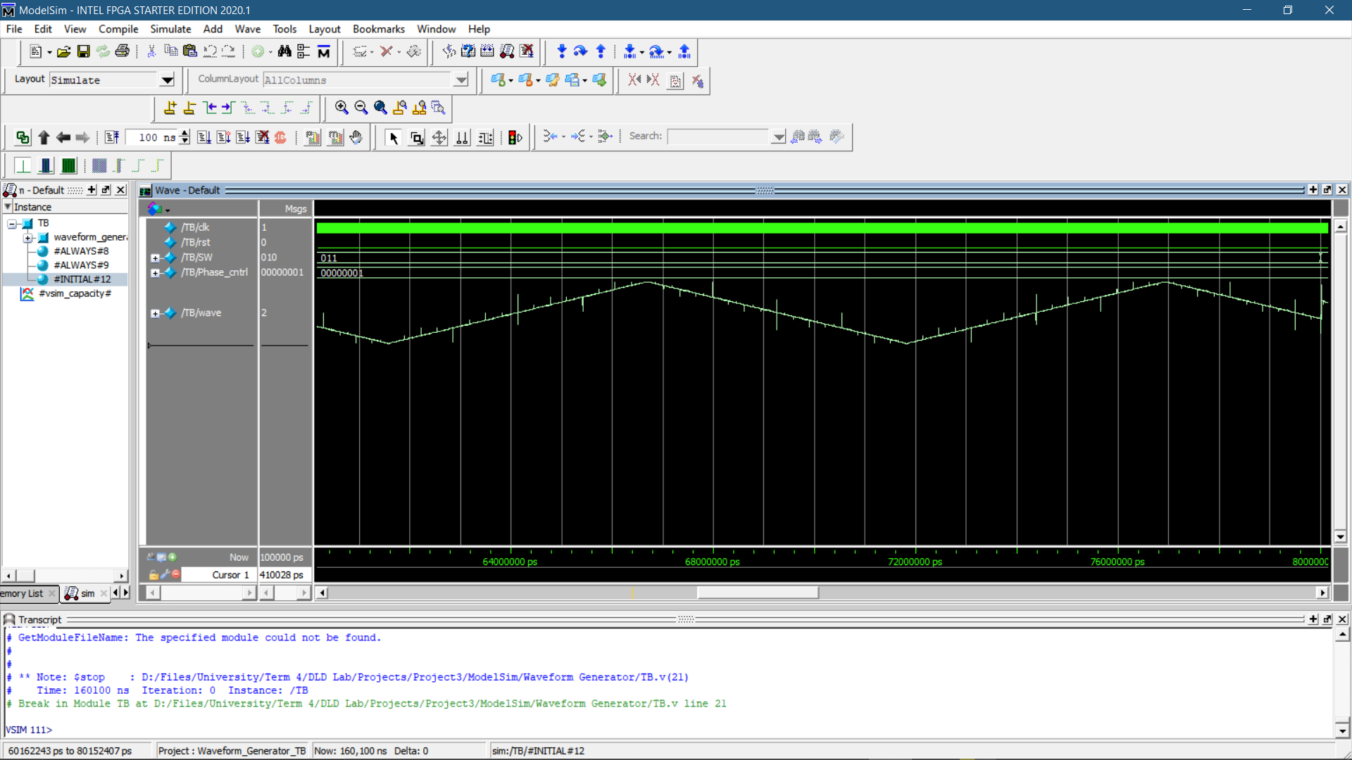

Fig. 4 Triangle waveform

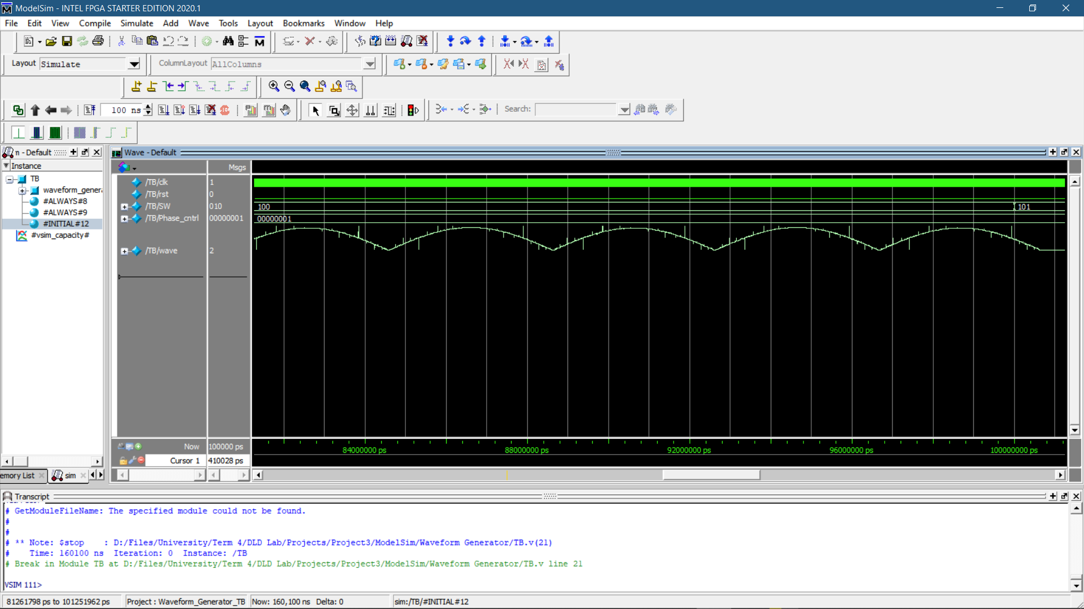

Fig. 5 Full wave rectified waveform

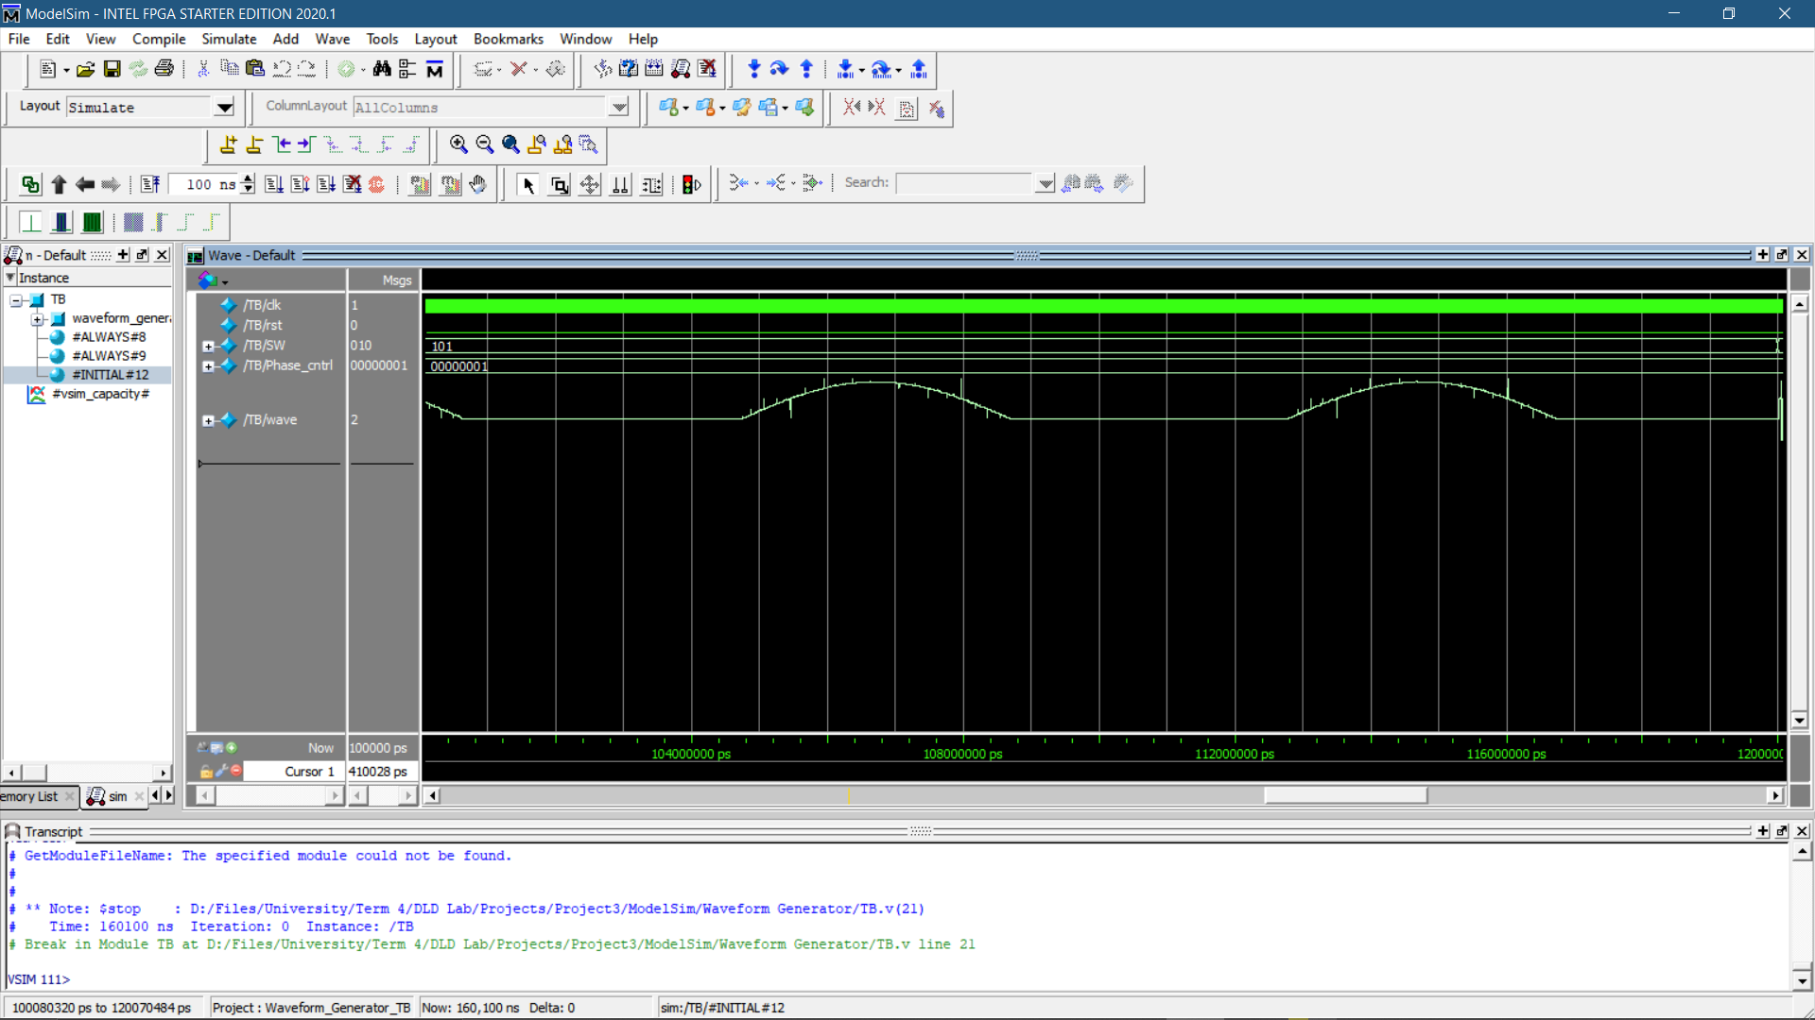

Fig. 6 Half wave rectified waveform

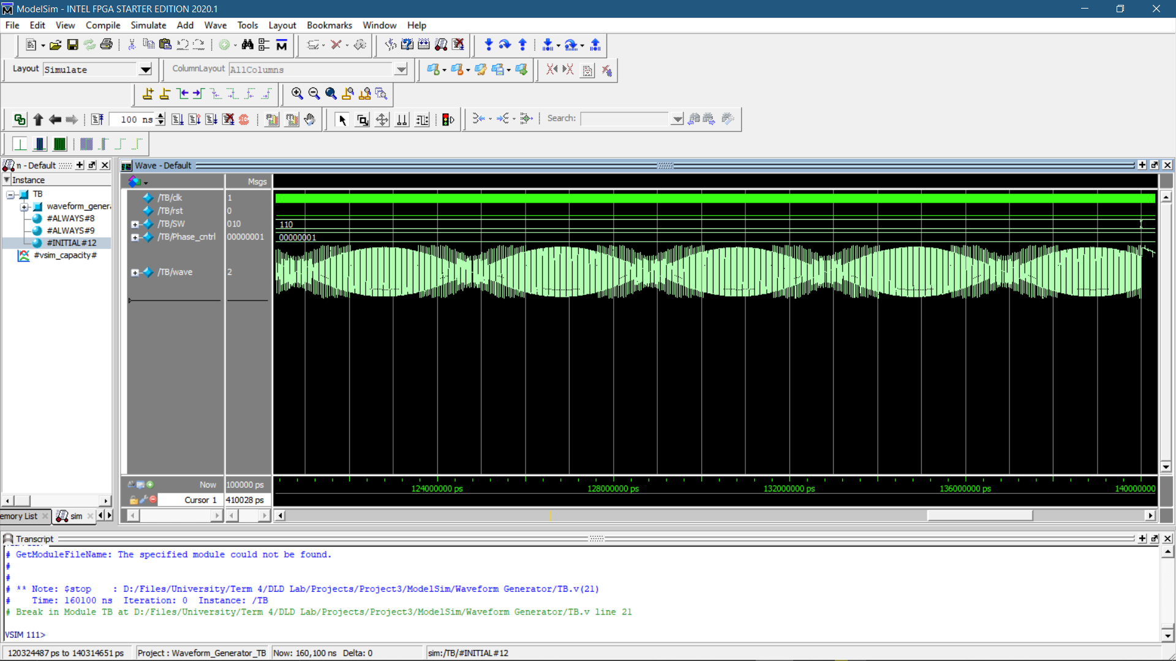

Fig. 7 Sinusoidally modulated square waveform

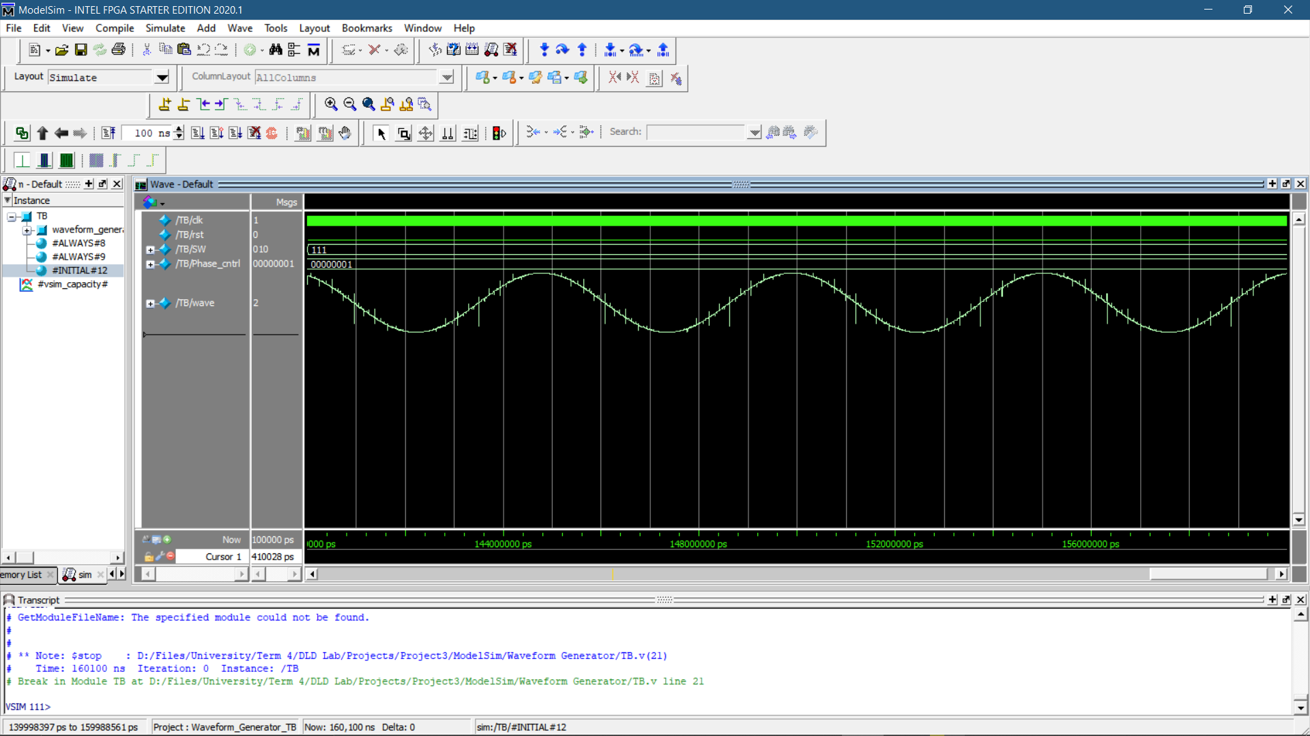

Fig. 8 DND waveform

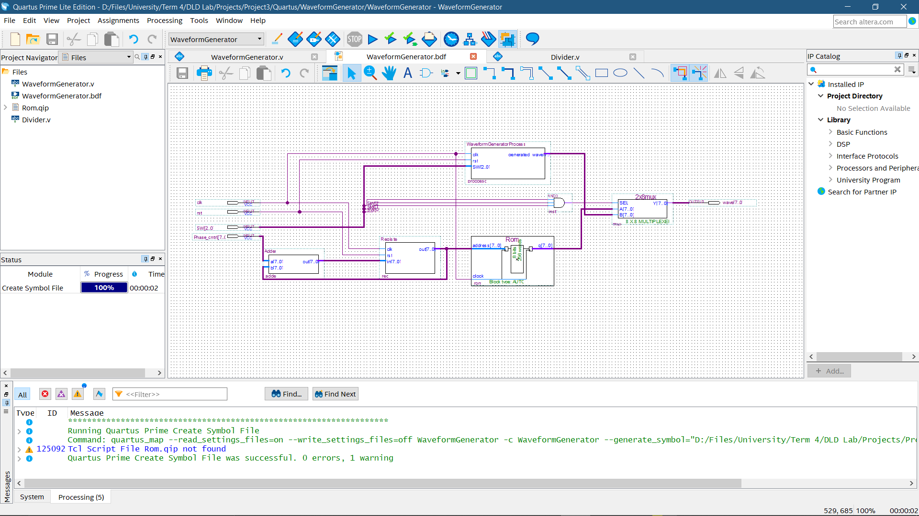

Fig. 9 Waveform generator

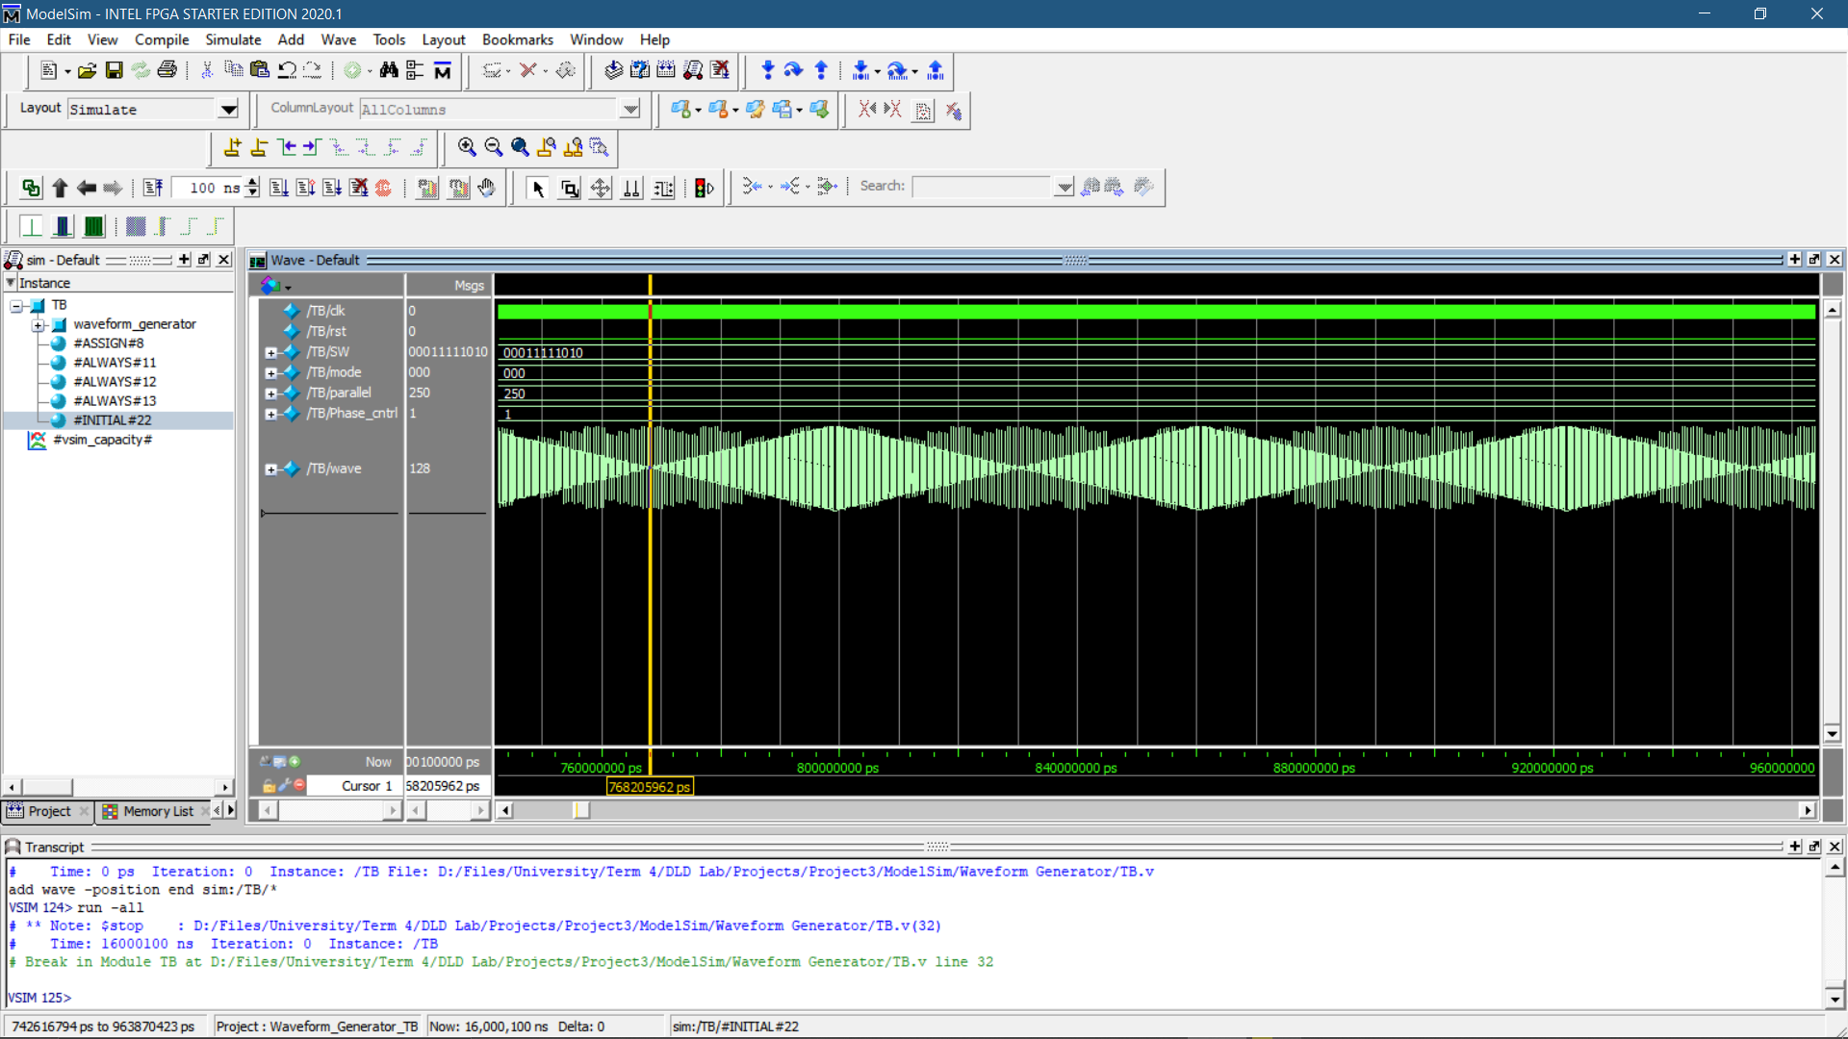

Fig. 10 Rhomboid wave, frequency = 16KHz

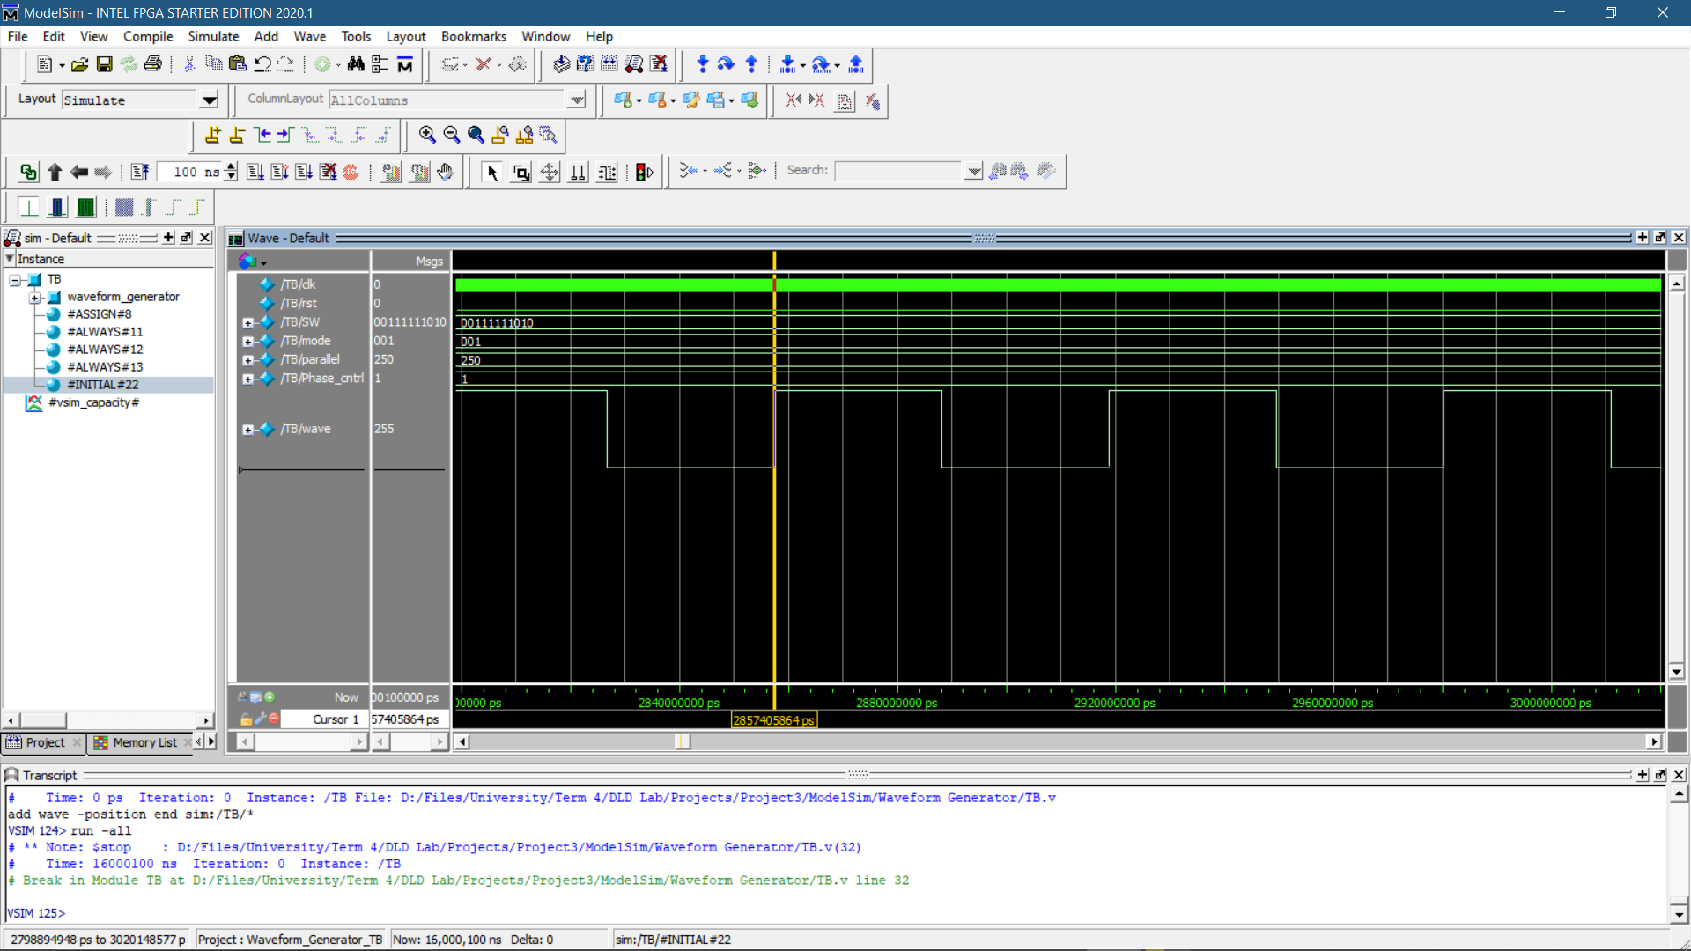

Fig. 11 Square wave, frequency = 16KHz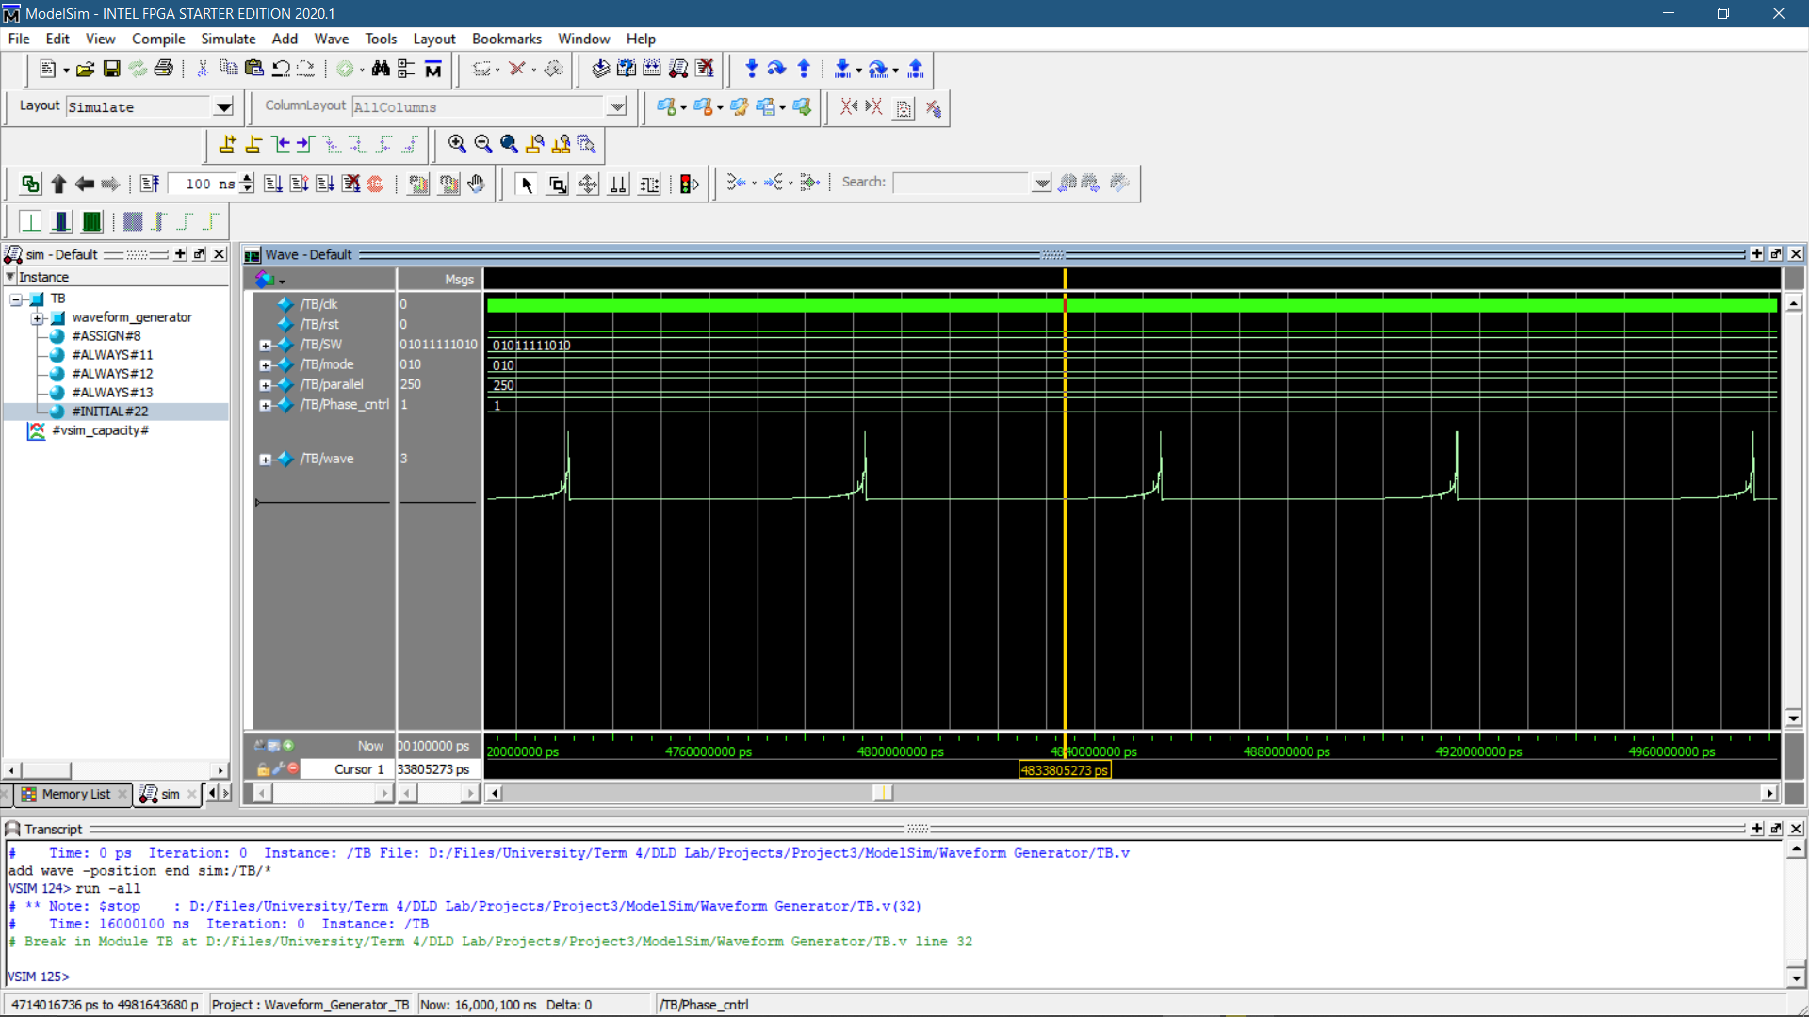

Fig. 12 Recirocal wave, frequency = 15KHz

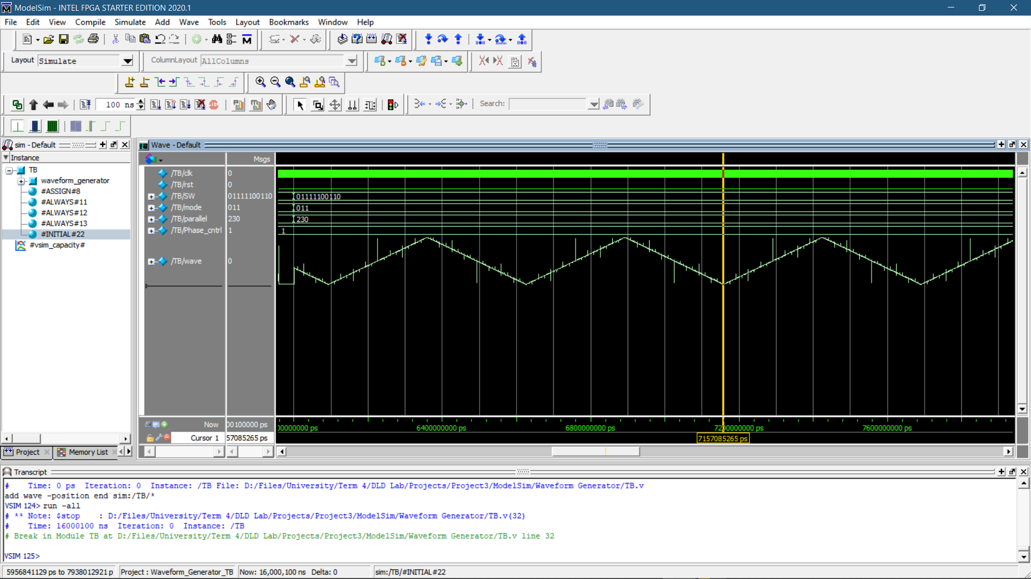

Fig. 13 Triangle wave, frequency = 1800Hz

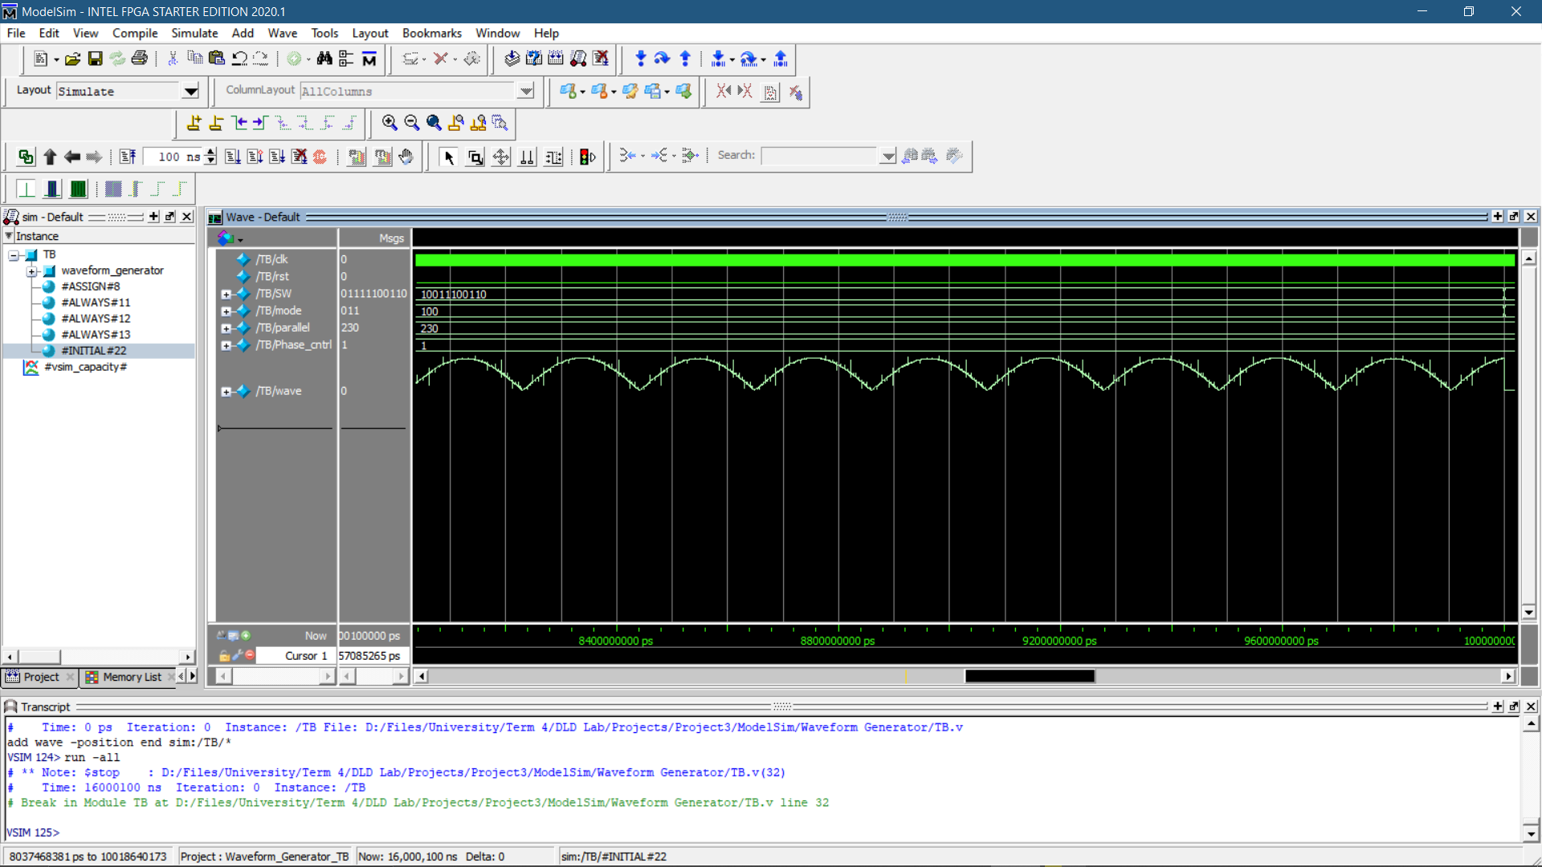

Fig. 14 Full wave rectified, frequency = 5KHz

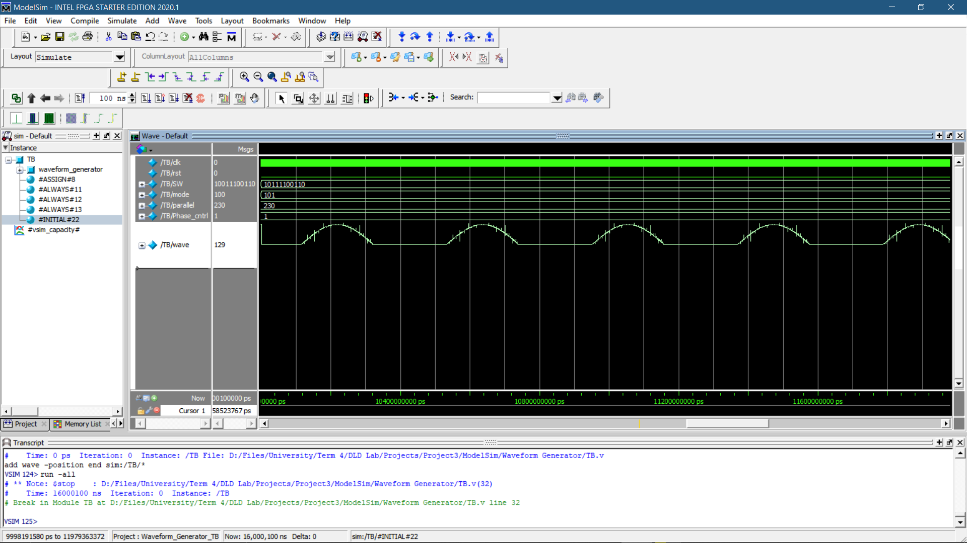

Fig. 15 Half wave rectified wave, frequency = 2300Hz

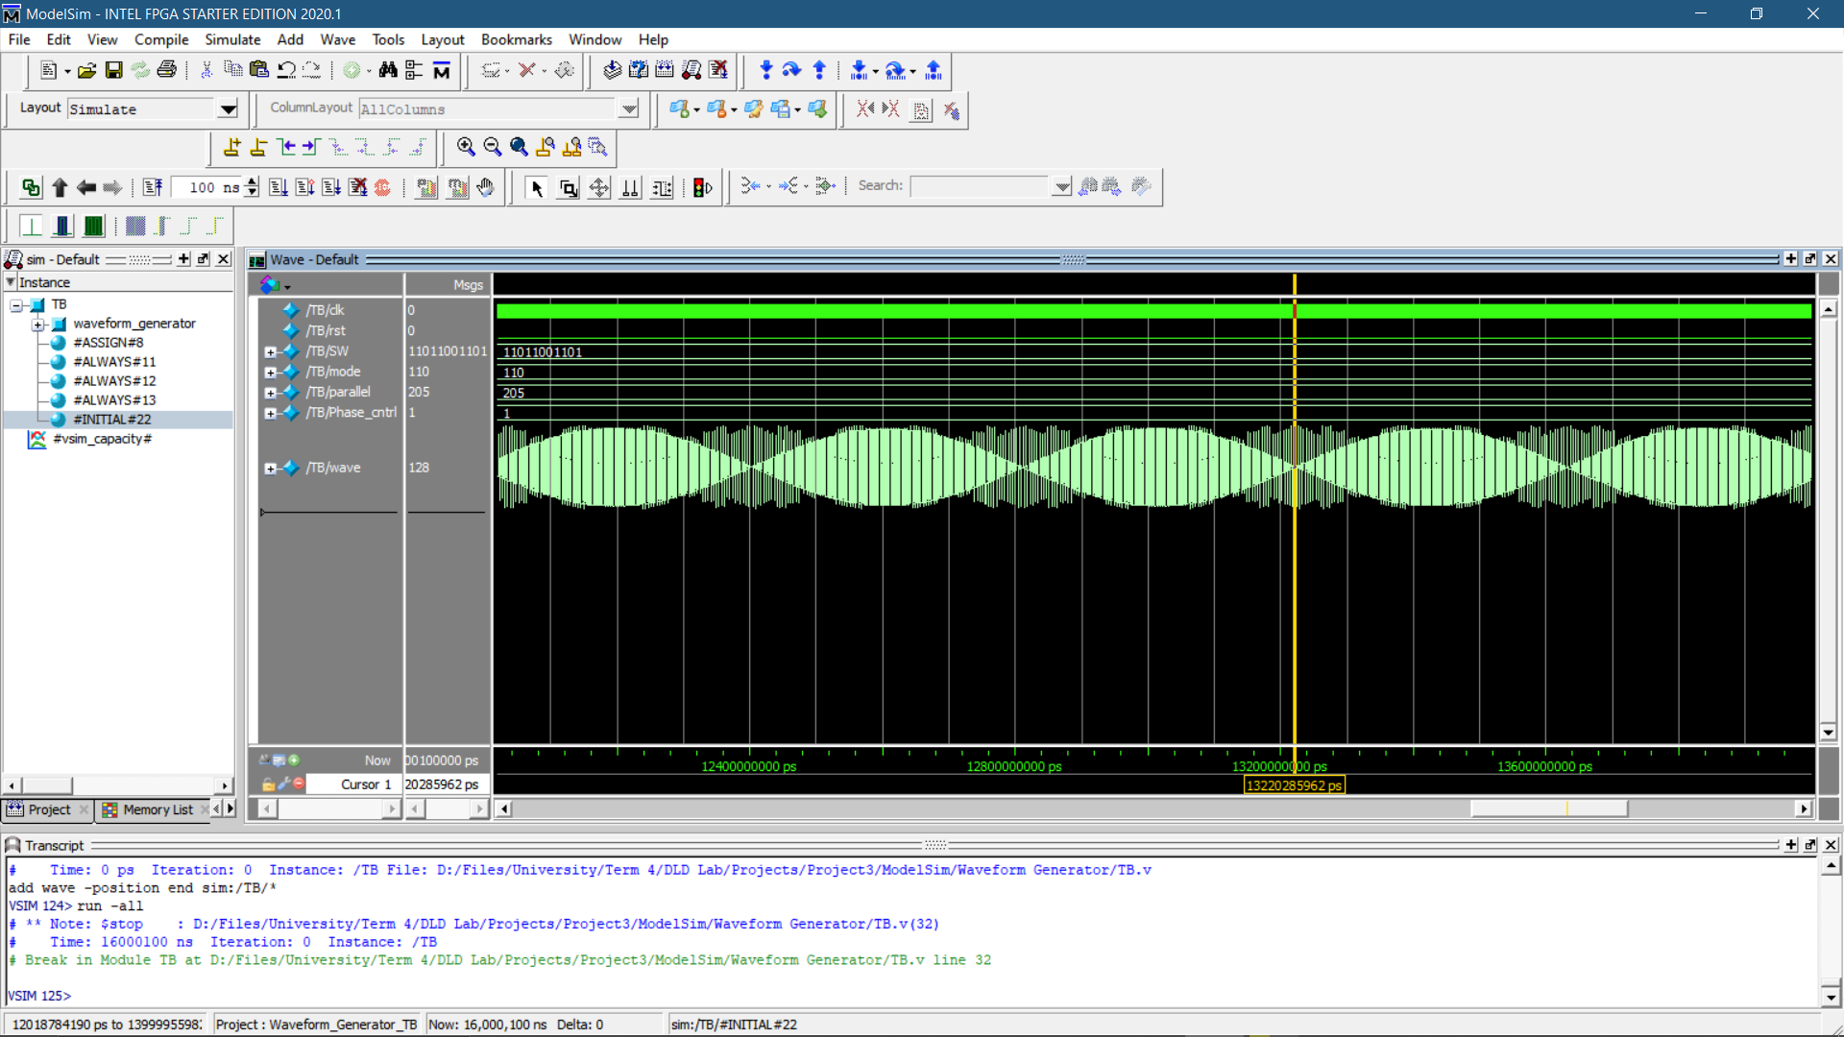

Fig. 16 Sinusoidally modulated square wave, frequency = 2500

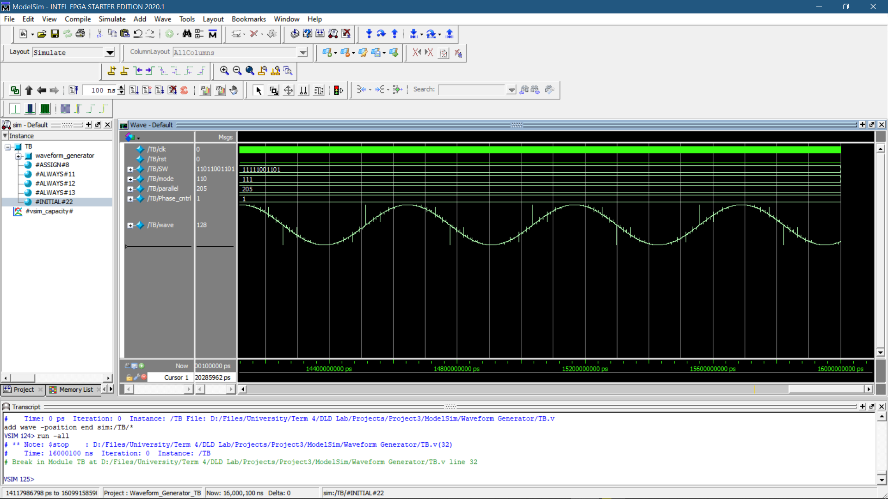

Fig. 17 DND wave, frequency = 2KHz

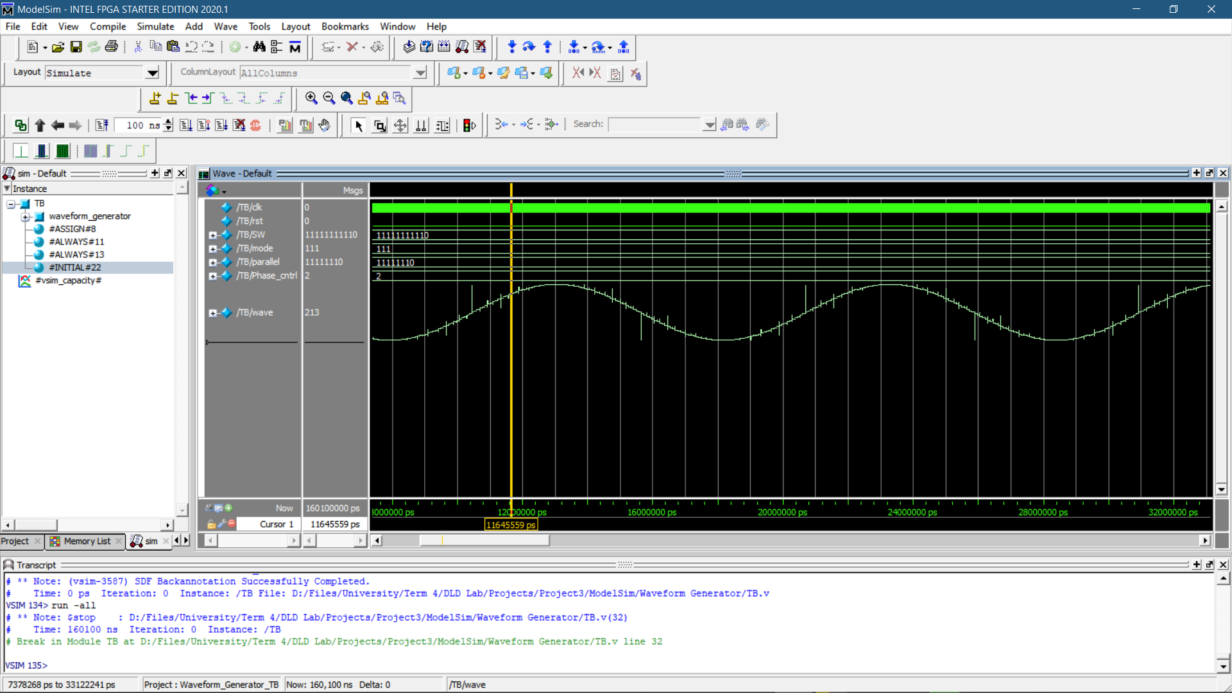

Fig. 18 Frequency = 200KHz

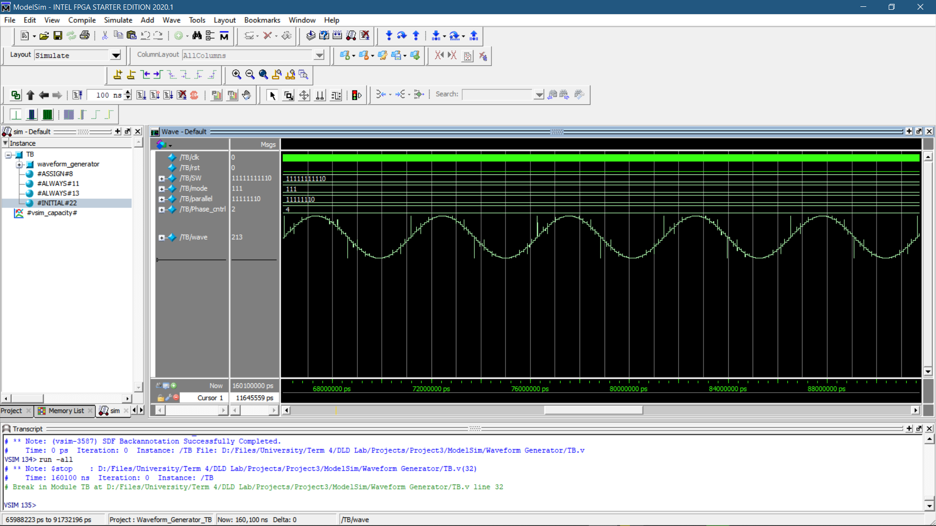

Fig. 19 Frequency = 400KHz

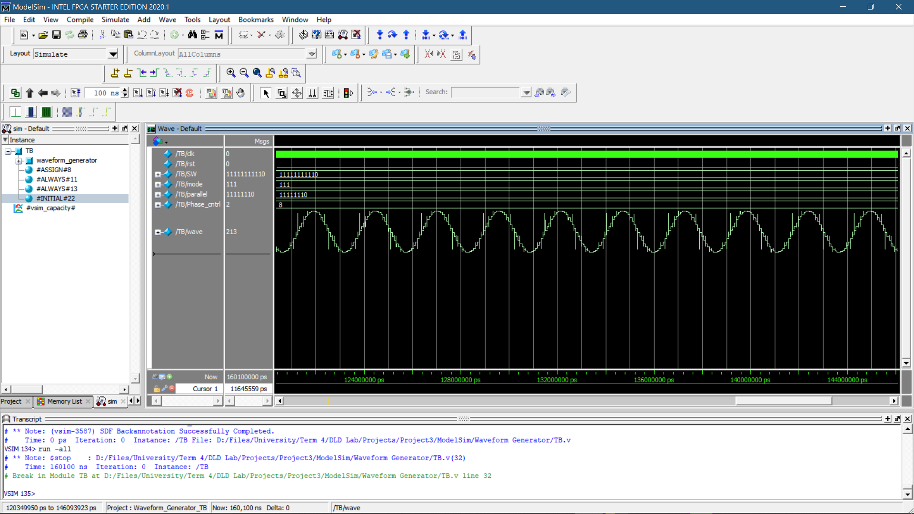

Fig. 20 Frequency = 800KHz

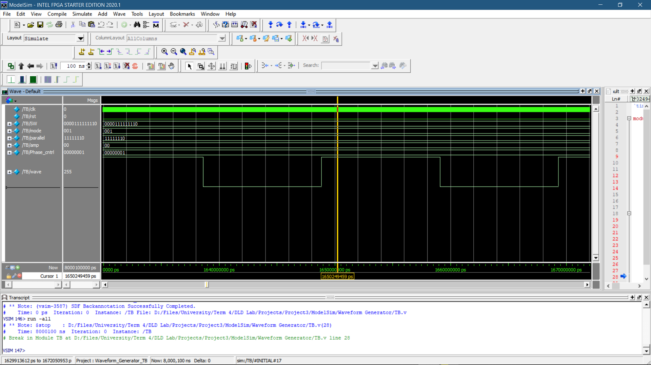

Fig. 21 Amplitude Selector input = 00

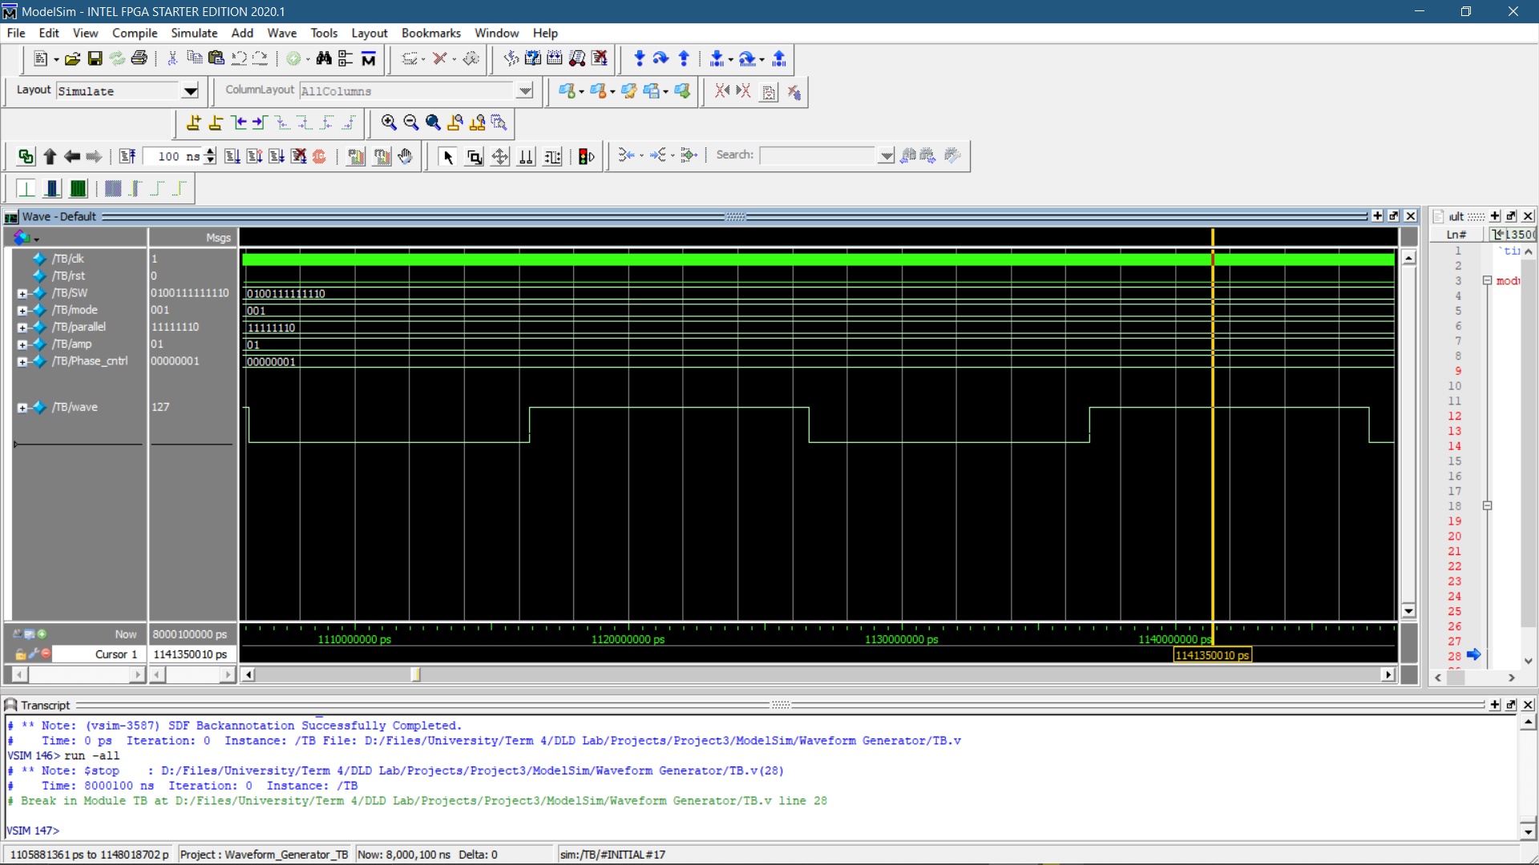

Fig. 22 Amplitude Selector input = 01

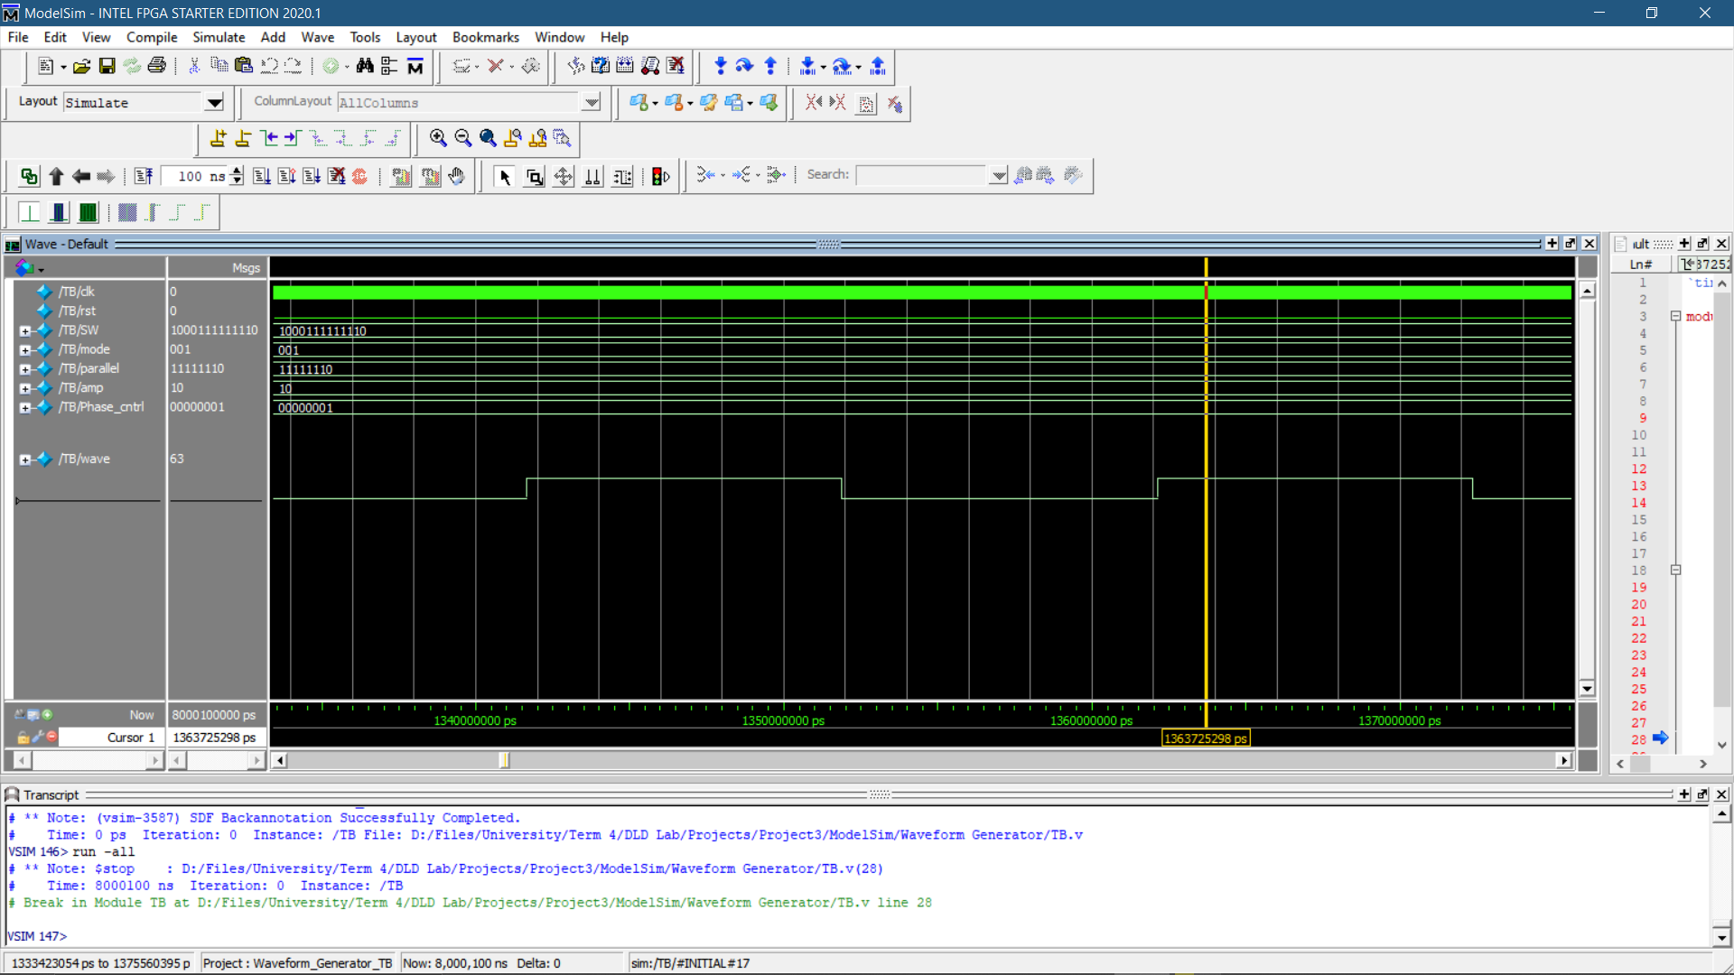

Fig. 23 Amplitude Selector input = 10

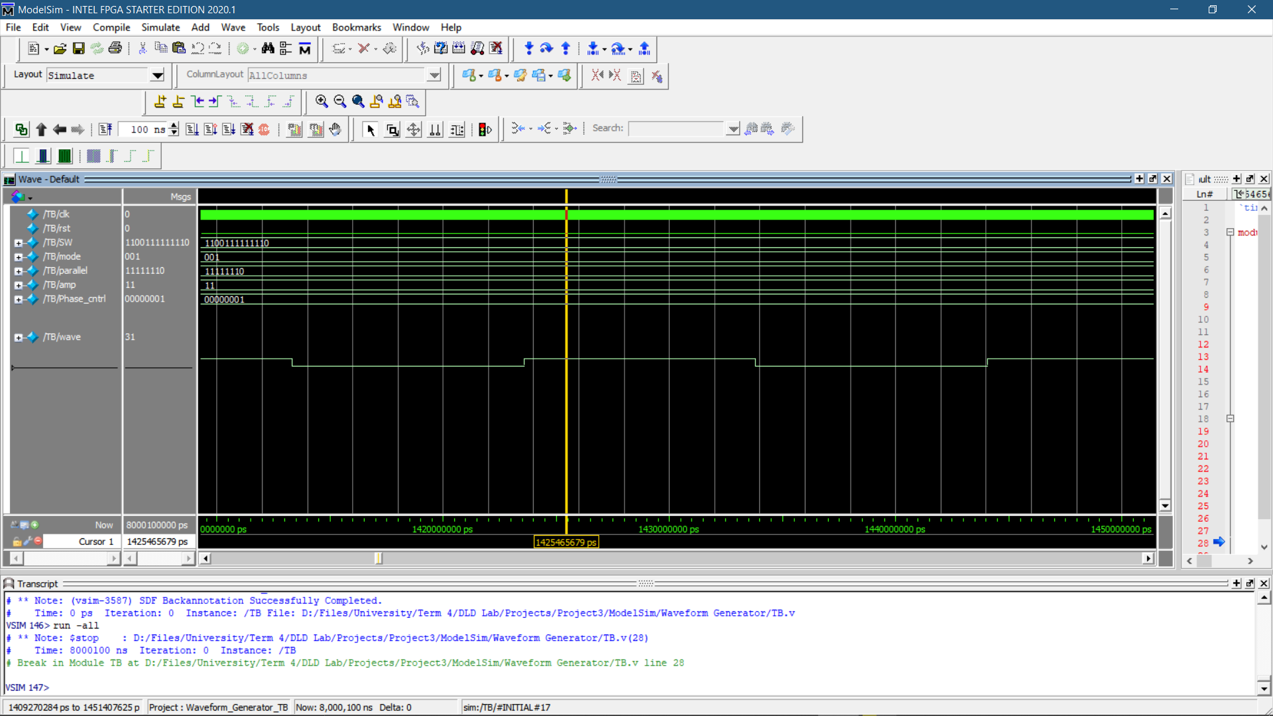

Fig. 24 Amplitude Selector input = 11

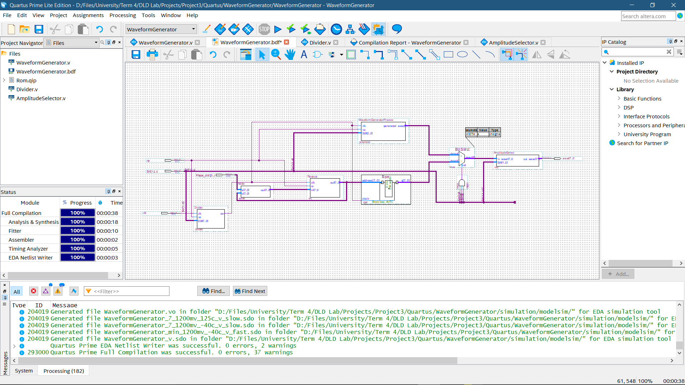

Fig. 25 Complete design